*OMISSIS*

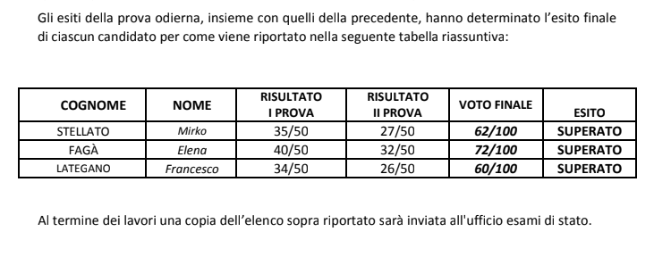

*OMISSIS*